What is Java?

Java is a **programming language** and a **platform**. Java is a high level, robust, object-oriented and secure programming language.

Java was developed by *Sun Microsystems* (which is now the subsidiary of Oracle) in the year 1995. *James Gosling* is known as the father of Java. Before Java, its name was *Oak*. Since Oak was already a registered company, so James Gosling and his team changed the name from Oak to Java.

## **Platform**: Any hardware or software environment in which a program runs, is known as a platforJava Example

Let's have a quick look at Java programming example. A detailed description of Hello Java example is available in next page.

**Simple.java**

1. **class** Simple{
2. **public** **static** **void** main(String args[]){
3. System.out.println("Hello Java");
4. }
5. }

m. Since Java has a runtime environment (JRE) and API, it is called a platform.

## Types of Java Applications

There are mainly 4 types of applications that can be created using Java programming:

#### **1) Standalone Application**

Standalone applications are also known as desktop applications or window-based applications. These are traditional software that we need to install on every machine. Examples of standalone application are Media player, antivirus, etc. AWT and Swing are used in Java for creating standalone applications.

#### **2) Web Application**

An application that runs on the server side and creates a dynamic page is called a web application. Currently, [Servlet](https://www.javatpoint.com/servlet-tutorial), [JSP](https://www.javatpoint.com/jsp-tutorial), [Struts](https://www.javatpoint.com/struts-2-tutorial), [Spring](https://www.javatpoint.com/spring-tutorial), [Hibernate](https://www.javatpoint.com/hibernate-tutorial), [JSF](https://www.javatpoint.com/jsf-tutorial), etc. technologies are used for creating web applications in Java.

#### **3) Enterprise Application**

An application that is distributed in nature, such as banking applications, etc. is called an enterprise application. It has advantages like high-level security, load balancing, and clustering. In Java, [EJB](https://www.javatpoint.com/ejb-tutorial) is used for creating enterprise applications.

#### **4) Mobile Application**

An application which is created for mobile devices is called a mobile application. Currently, Android and Java ME are used for creating mobile applications.

## Java Platforms / Editions

There are 4 platforms or editions of Java:

#### **1) Java SE (Java Standard Edition)**

It is a Java programming platform. It includes Java programming APIs such as java.lang, java.io, java.net, java.util, java.sql, java.math etc. It includes core topics like OOPs, [String](https://www.javatpoint.com/java-string), Regex, Exception, Inner classes, Multithreading, I/O Stream, Networking, AWT, Swing, Reflection, Collection, etc.

#### **2) Java EE (Java Enterprise Edition)**

It is an enterprise platform that is mainly used to develop web and enterprise applications. It is built on top of the Java SE platform. It includes topics like Servlet, JSP, Web Services, EJB, [JPA](https://www.javatpoint.com/jpa-tutorial), etc.

#### **3) Java ME (Java Micro Edition)**

It is a micro platform that is dedicated to mobile applications.

#### **4) JavaFX**

It is used to develop rich internet applications. It uses a lightweight user interface API.

Release Versions in java:

1. JDK Alpha and Beta (1995)
2. JDK 1.0 (23rd Jan 1996)
3. JDK 1.1 (19th Feb 1997)
4. J2SE 1.2 (8th Dec 1998)
5. J2SE 1.3 (8th May 2000)
6. J2SE 1.4 (6th Feb 2002)
7. J2SE 5.0 (30th Sep 2004)
8. Java SE 6 (11th Dec 2006)
9. Java SE 7 (28th July 2011)
10. Java SE 8 (18th Mar 2014)
11. Java SE 9 (21st Sep 2017)
12. Java SE 10 (20th Mar 2018)
13. Java SE 11 (September 2018)
14. Java SE 12 (March 2019)
15. Java SE 13 (September 2019)
16. Java SE 14 (Mar 2020)
17. Java SE 15 (September 2020)
18. Java SE 16 (Mar 2021)
19. Java SE 17 (September 2021)
20. Java SE 18 (to be released by March 2022)

# **Features of Java**

The primary objective of [Java programming](https://www.javatpoint.com/java-tutorial) language creation was to make it portable, simple and secure programming language. Apart from this, there are also some excellent features which play an important role in the popularity of this language. The features of Java are also known as Java buzzwords.

A list of the most important features of the Java language is given below.

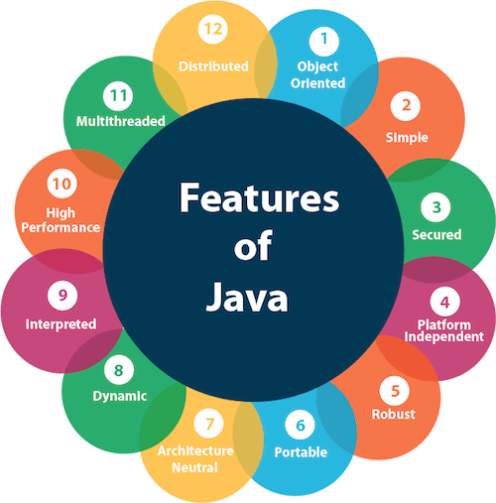

1. [Simple](https://www.javatpoint.com/features-of-java#Simple)
2. [Object-Oriented](https://www.javatpoint.com/features-of-java#Object-Oriented)
3. [Portable](https://www.javatpoint.com/features-of-java#Portable)
4. [Platform independent](https://www.javatpoint.com/features-of-java#Platform-independent)
5. [Secured](https://www.javatpoint.com/features-of-java#Secured)
6. [Robust](https://www.javatpoint.com/features-of-java#Robust)
7. [Architecture neutral](https://www.javatpoint.com/features-of-java#Architecture-neutral)
8. [Interpreted](https://www.javatpoint.com/features-of-java#Interpreted)
9. [High Performance](https://www.javatpoint.com/features-of-java#High-Performance)
10. [Multithreaded](https://www.javatpoint.com/features-of-java#Multithreaded)
11. [Distributed](https://www.javatpoint.com/features-of-java#Distributed)
12. [Dynamic](https://www.javatpoint.com/features-of-java#Dynamic)

### **Simple**

Java is very easy to learn, and its syntax is simple, clean and easy to understand. According to Sun Microsystem, Java language is a simple programming language because:

* Java syntax is based on C++ (so easier for programmers to learn it after C++).
* Java has removed many complicated and rarely-used features, for example, explicit pointers, operator overloading, etc.
* There is no need to remove unreferenced objects because there is an Automatic Garbage Collection in Java.

### **Object-oriented**

Java is an [object-oriented](https://www.javatpoint.com/java-oops-concepts) programming language. Everything in Java is an object. Object-oriented means we organize our software as a combination of different types of objects that incorporate both data and behavior.

Object-oriented programming (OOPs) is a methodology that simplifies software development and maintenance by providing some rules.

Basic concepts of OOPs are:

1. [Object](https://www.javatpoint.com/object-and-class-in-java)
2. [Class](https://www.javatpoint.com/object-and-class-in-java#class)
3. [Inheritance](https://www.javatpoint.com/inheritance-in-java)
4. [Polymorphism](https://www.javatpoint.com/runtime-polymorphism-in-java)
5. [Abstraction](https://www.javatpoint.com/abstract-class-in-java)
6. [Encapsulation](https://www.javatpoint.com/encapsulation)

### **Platform Independent**

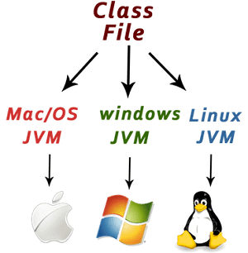

Java is platform independent because it is different from other languages like [C](https://www.javatpoint.com/c-programming-language-tutorial), [C++](https://www.javatpoint.com/cpp-tutorial), etc. which are compiled into platform specific machines while Java is a write once, run anywhere language. A platform is the hardware or software environment in which a program runs.

There are two types of platforms software-based and hardware-based. Java provides a software-based platform.

The Java platform differs from most other platforms in the sense that it is a software-based platform that runs on top of other hardware-based platforms. It has two components:

1. Runtime Environment
2. API(Application Programming Interface)

Java code can be executed on multiple platforms, for example, Windows, Linux, Sun Solaris, Mac/OS, etc. Java code is compiled by the compiler and converted into bytecode. This bytecode is a platform-independent code because it can be run on multiple platforms, i.e., Write Once and Run Anywhere (WORA).

### **Secured**

Java is best known for its security. With Java, we can develop virus-free systems. Java is secured because:

* **No explicit pointer**
* **Java Programs run inside a virtual machine sandbox**

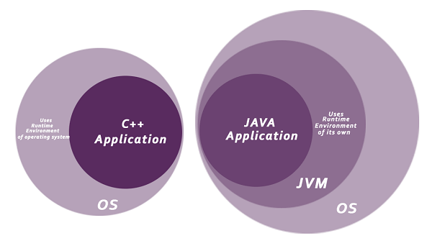

Java language provides these securities by default. Some security can also be provided by an application developer explicitly through SSL, JAAS, Cryptography, etc.

### **Robust**

The English mining of Robust is strong. Java is robust because:

* It uses strong memory management.
* There is a lack of pointers that avoids security problems.
* Java provides automatic garbage collection which runs on the Java Virtual Machine to get rid of objects which are not being used by a Java application anymore.
* There are exception handling and the type checking mechanism in Java. All these points make Java robust.

### **Architecture-neutral**

Java is architecture neutral because there are no implementation dependent features, for example, the size of primitive types is fixed.

In C programming, int data type occupies 2 bytes of memory for 32-bit architecture and 4 bytes of memory for 64-bit architecture. However, it occupies 4 bytes of memory for both 32 and 64-bit architectures in Java.

### **Portable**

Java is portable because it facilitates you to carry the Java bytecode to any platform. It doesn't require any implementation.

### **High-performance**

Java is faster than other traditional interpreted programming languages because Java bytecode is "close" to native code. It is still a little bit slower than a compiled language (e.g., C++). Java is an interpreted language that is why it is slower than compiled languages, e.g., C, C++, etc.

### **Distributed**

Java is distributed because it facilitates users to create distributed applications in Java. RMI and EJB are used for creating distributed applications. This feature of Java makes us able to access files by calling the methods from any machine on the internet.

### **Multi-threaded**

A thread is like a separate program, executing concurrently. We can write Java programs that deal with many tasks at once by defining multiple threads. The main advantage of multi-threading is that it doesn't occupy memory for each thread. It shares a common memory area. Threads are important for multi-media, Web applications, etc.

### **Dynamic**

Java is a dynamic language. It supports the dynamic loading of classes. It means classes are loaded on demand. It also supports functions from its native languages, i.e., C and C++.

# **First Java Program | Hello World Example**

1. [Software Requirements](https://www.javatpoint.com/simple-program-of-java#hellojavareq)
2. [Creating Hello Java Example](https://www.javatpoint.com/simple-program-of-java#hellojavaex)
3. [Resolving javac is not recognized](https://www.javatpoint.com/simple-program-of-java#hellojavawhatjavacnot)

In this section, we will learn how to write the simple program of Java. We can write a simple hello Java program easily after installing the JDK.

To create a simple Java program, you need to create a class that contains the main method. Let's understand the requirement first.

### **The requirement for Java Hello World Example**

For executing any Java program, the following software or application must be properly installed.

* Install the JDK if you don't have installed it, [download the JDK](http://www.oracle.com/technetwork/java/javase/downloads/index.html) and install it.
* Set path of the jdk/bin directory. [http://www.javatpoint.com/how-to-set-path-in-java](https://www.javatpoint.com/how-to-set-path-in-java)
* Create the Java program
* Compile and run the Java program

### **Creating Hello World Example**

Let's create the hello java program:

1. **class** Simple{
2. **public** **static** **void** main(String args[]){
3. System.out.println("Hello Java");
4. }
5. }

[**Test it Now**](https://www.javatpoint.com/opr/test.jsp?filename=Simple)

Save the above file as Simple.java.

|  |  |
| --- | --- |
| **To compile:** | javac Simple.java |
| **To execute:** | java Simple |

**Output:**

Hello Java

**Compilation Flow:**

When we compile Java program using javac tool, the Java compiler converts the source code into byte code.

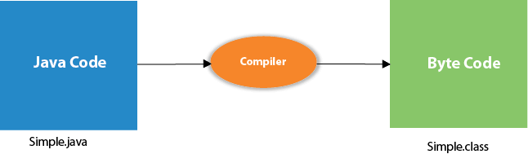

## Parameters used in First Java Program

Let's see what is the meaning of class, public, static, void, main, String[], System.out.println().

* **class** keyword is used to declare a class in Java.
* **public** keyword is an access modifier that represents visibility. It means it is visible to all.
* **static** is a keyword. If we declare any method as static, it is known as the static method. The core advantage of the static method is that there is no need to create an object to invoke the static method. The main() method is executed by the JVM, so it doesn't require creating an object to invoke the main() method. So, it saves memory.
* **void** is the return type of the method. It means it doesn't return any value.
* **main** represents the starting point of the program.
* **String[] args** or **String args[]** is used for [command line argument](https://www.javatpoint.com/command-line-argument). We will discuss it in coming section.
* **System.out.println()** is used to print statement. Here, System is a class, out is an object of the PrintStream class, println() is a method of the PrintStream class. We will discuss the internal working of [System.out.println()](https://www.javatpoint.com/system-out-println-in-java) statement in the coming section.

To write the simple program, you need to open notepad by **start menu -> All Programs -> Accessories -> Notepad** and write a simple program as we have shownbelow:

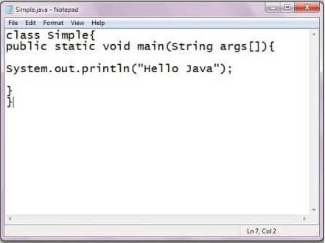

As displayed in the above diagram, write the simple program of Java in notepad and saved it as Simple.java. In order to compile and run the above program, you need to open the command prompt by **start menu -> All Programs -> Accessories -> command prompt**. When we have done with all the steps properly, it shows the following output:

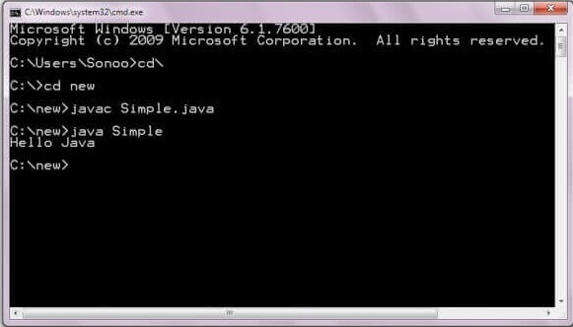

To compile and run the above program, go to your current directory first; my current directory is c:\new. Write here:

|  |  |
| --- | --- |
| **To compile:** | javac Simple.java |
| **To execute:** | java Simple |

## In how many ways we can write a Java program?

There are many ways to write a Java program. The modifications that can be done in a Java program are given below:

**1) By changing the sequence of the modifiers, method prototype is not changed in Java.**

Let's see the simple code of the main method.

1. **static** **public** **void** main(String args[])

**2) The subscript notation in the Java array can be used after type, before the variable or after the variable.**

Let's see the different codes to write the main method.

1. **public** **static** **void** main(String[] args)
2. **public** **static** **void** main(String []args)
3. **public** **static** **void** main(String args[])

**3) You can provide var-args support to the main() method by passing 3 ellipses (dots)**

Let's see the simple code of using var-args in the main() method. We will learn about var-args later in the Java New Features chapter.

1. **public** **static** **void** main(String... args)

**4) Having a semicolon at the end of class is optional in Java.**

Let's see the simple code.

1. **class** A{
2. **static** **public** **void** main(String... args){
3. System.out.println("hello java4");
4. }
5. };

## Valid Java main() method signature

1. **public** **static** **void** main(String[] args)
2. **public** **static** **void** main(String []args)
3. **public** **static** **void** main(String args[])
4. **public** **static** **void** main(String... args)
5. **static** **public** **void** main(String[] args)
6. **public** **static** **final** **void** main(String[] args)
7. **final** **public** **static** **void** main(String[] args)
8. **final** **strictfp** **public** **static** **void** main(String[] args)

### **Resolving an error "javac is not recognized as an internal or external command"?**

If there occurs a problem like displayed in the below figure, you need to set a path. Since DOS doesn't recognize javac and java as internal or external command. To overcome this problem, we need to set a path. The path is not required in a case where you save your program inside the JDK/bin directory. However, it is an excellent approach to set the path. Click here for [How to set path in java](https://www.javatpoint.com/how-to-set-path-in-java).

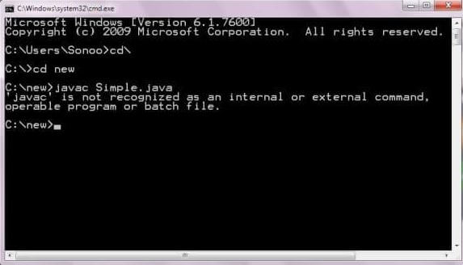

# **Internal Details of Hello Java Program**

## What happens at compile time?

At compile time, the Java file is compiled by Java Compiler (It does not interact with OS) and converts the Java code into bytecode.



## What happens at runtime?

At runtime, the following steps are performed:

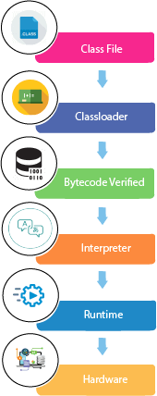

**Classloader:** It is the subsystem of JVM that is used to load class files.

24.3M

457

Prime Ministers of India | List of Prime Minister of India (1947-2020)

**Bytecode Verifier:** Checks the code fragments for illegal code that can violate access rights to objects.

**Interpreter:** Read bytecode stream then execute the instructions.

### **Q) Can you save a Java source file by another name than the class name?**

Yes, if the class is not public. It is explained in the figure given below:

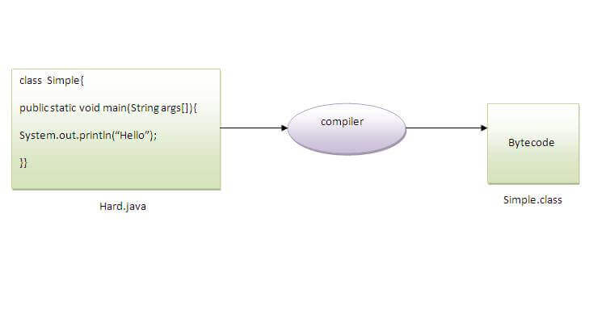

|  |  |
| --- | --- |
| **To compile:** | javac Hard.java |
| **To execute:** | java Simple |

Observe that, we have compiled the code with file name but running the program with class name. Therefore, we can save a Java program other than class name.

### **Q) Can you have multiple classes in a java source file?**

Yes, like the figure given below illustrates:

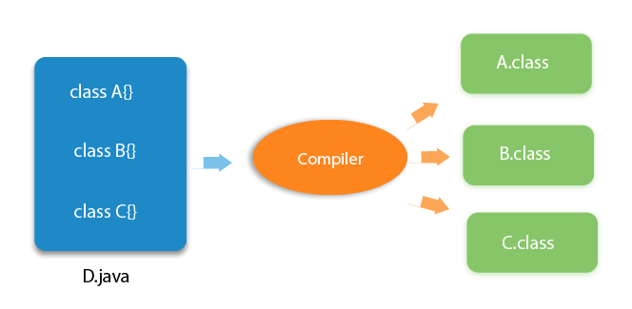

# **How to set path in Java**

1. [How to set the path of JDK in Windows OS](https://www.javatpoint.com/how-to-set-path-in-java)
   1. [Setting Temporary Path of JDK](https://www.javatpoint.com/how-to-set-path-in-java#pathtemporary)
   2. [Setting Permanent Path of JDK](https://www.javatpoint.com/how-to-set-path-in-java#pathpermanent)
2. [How to set the path of JDK in Linux OS](https://www.javatpoint.com/how-to-set-path-in-java#pathlinux)

The path is required to be set for using tools such as javac, java, etc.

If you are saving the Java source file inside the JDK/bin directory, the path is not required to be set because all the tools will be available in the current directory.

However, if you have your Java file outside the JDK/bin folder, it is necessary to set the path of JDK.

There are two ways to set the path in Java:

35.9M

597

Hello Java Program for Beginners

1. Temporary
2. Permanent

## 1) How to set the Temporary Path of JDK in Windows

To set the temporary path of JDK, you need to follow the following steps:

* Open the command prompt
* Copy the path of the JDK/bin directory
* Write in command prompt: set path=copied\_path

### **For Example:**

set path=C:\Program Files\Java\jdk1.6.0\_23\bin

Let's see it in the figure given below:

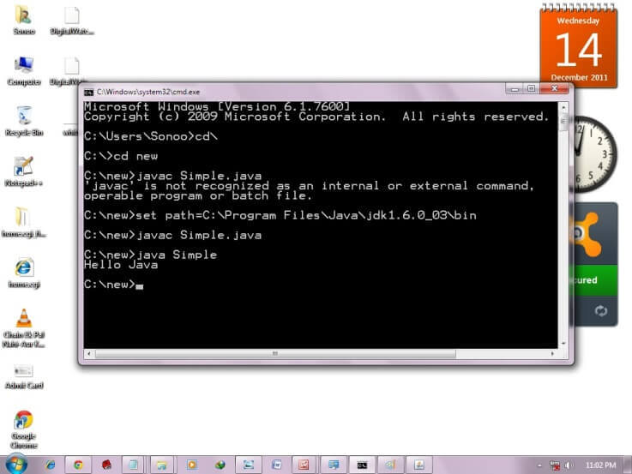

## 2) How to set Permanent Path of JDK in Windows

For setting the permanent path of JDK, you need to follow these steps:

* Go to MyComputer properties -> advanced tab -> environment variables -> new tab of user variable -> write path in variable name -> write path of bin folder in variable value -> ok -> ok -> ok

### **For Example:**

|  |
| --- |
| **1) Go to MyComputer properties** |
| how to set path in java |
| **2) Click on the advanced tab** |
| how to set path in java |
| **3) Click on environment variables** |
| how to set path in java |
| **4) Click on the new tab of user variables** |
| how to set path in java |
| **5) Write the path in the variable name** |
| how to set path in java |
| **6) Copy the path of bin folder** |
| how to set path in java |
| **7) Paste path of bin folder in the variable value** |
| how to set path in java |
| **8) Click on ok button** |
| how to set path in java |
| **9) Click on ok button** |
| how to set path in java |

Now your permanent path is set. You can now execute any program of java from any drive.

### **Setting Java Path in Linux OS**

Setting path in Linux OS is the same as setting the path in the Windows OS. But, here we use the export tool rather than set. Let's see how to set path in Linux OS:

export PATH=$PATH:/home/jdk1.6.01/bin/

Here, we have installed the JDK in the home directory under Root (/home).

Java Coding Standards:

## Naming Conventions of the Different Identifiers

The following table shows the popular conventions used for the different identifiers.

|  |  |  |
| --- | --- | --- |
| **Identifiers Type** | **Naming Rules** | **Examples** |
| Class | It should start with the uppercase letter. It should be a noun such as Color, Button, System, Thread, etc. Use appropriate words, instead of acronyms. | public  class **Employee** { //code snippet } |
| Interface | It should start with the uppercase letter. It should be an adjective such as Runnable, Remote, ActionListener. Use appropriate words, instead of acronyms. | interface **Printable** { //code snippet } |
| Method | It should start with lowercase letter. It should be a verb such as main(), print(), println(). If the name contains multiple words, start it with a lowercase letter followed by an uppercase letter such as actionPerformed(). | class  Employee { //  method void **drawDisplay()** { //code snippet } } |
| Variable | It should start with a lowercase letter such as id, name. It should not start with the special characters like & (ampersand), $ (dollar), \_ (underscore). If the name contains multiple words, start it with the lowercase letter followed by an uppercase letter such as firstName, lastName. Avoid using one-character variables such as x, y, z. | ClassEmployee { // variable int **id**; //code snippet } |
| Package | It should be a lowercase letter such as java, lang. If the name contains multiple words, it should be separated by dots (.) such as java.util, java.lang. | //package package**com.javapoint;** classEmployee { //code snippet } |
| Constant | It should be in uppercase letters such as RED, YELLOW. If the name contains multiple words, it should be separated by an underscore(\_) such as MAX\_PRIORITY. It may contain digits but not as the first letter. | classEmployee { //constant static final int  **MIN\_AGE** = 18; //code snippet } |

Control Statements in java:

* [Simple if statement](https://www.edureka.co/blog/control-statements-in-java/#Simpleifstatement)
* [if-else statement](https://www.edureka.co/blog/control-statements-in-java/#if-elsestatement)
* [Nested if statement](https://www.edureka.co/blog/control-statements-in-java/#Nestedifstatement)
* [Switch statement](https://www.edureka.co/blog/control-statements-in-java/#Switchstatement)
* [Looping statements](https://www.edureka.co/blog/control-statements-in-java/#Loopingstatemenets)
* [While](https://www.edureka.co/blog/control-statements-in-java/#While)
* [Do-while](https://www.edureka.co/blog/control-statements-in-java/#Do-while)
* [For](https://www.edureka.co/blog/control-statements-in-java/#For)
* [For-Each](https://www.edureka.co/blog/control-statements-in-java/#For-Each)
* [Branching statements](https://www.edureka.co/blog/control-statements-in-java/#Branchingstatements)
* [Break](https://www.edureka.co/blog/control-statements-in-java/#Break)
* [Continue](https://www.edureka.co/blog/control-statements-in-java/#Continue)
* **Simple if statement**
* The if statement determines whether a code should be executed based on the specified condition.  
  **Syntax:**

|  |  |
| --- | --- |
| 1  2  3  4 | if (condition) {  Statement 1; //executed if condition is true  }  Statement 2; //executed irrespective of the condition |

**If.**.**else statement**

In this statement, if the condition specified is true, the if block is executed. Otherwise, the else block is executed.  
**Example:**

|  |  |
| --- | --- |
| 1  2  3  4  5  6  7  8  9  10  11  12  13 | public class Main  {  public static void main(String args[])  {  int a = 15;  if (a > 20)  System.out.println("a is greater than 10");  else  System.out.println("a is less than 10");  System.out.println("Hello World!");  }  }  } |

**Output:**  
a is less than 10  
Hello World!

**Nested if statement**

An if present inside an if block is known as a nested if block. It is similar to an if..else statement, except they are defined inside another if..else statement.  
**Syntax:**

|  |  |
| --- | --- |
| 1  2  3  4  5  6  7  8  9 | if (condition1) {  Statement 1; //executed if first condition is true  if (condition2) {  Statement 2; //executed if second condition is true  }  else {  Statement 3; //executed if second condition is false  }  } |

**Example:**

|  |  |
| --- | --- |
| 1  2  3  4  5  6  7  8  9  10  11  12  13  14  15  16  17  18  19 | public class Main  {  public static void main(String args[])  {  int s = 18;  if (s > 10)  {  if (s%2==0)  System.out.println("s is an even number and greater than 10!");  else  System.out.println("s is a odd number and greater than 10!");  }  else  {  System.out.println("s is less than 10");  }  System.out.println("Hello World!");  }  } |

**Output:**  
s is an even number and greater than 10!  
Hello World!

## ****Switch statement****

A switch statement in java is used to execute a single statement from multiple conditions. The switch statement can be used with short, byte, int, long, enum types, etc.

**Example:**

|  |  |
| --- | --- |
| 1  2  3  4  5  6  7  8  9  10  11  12  13  14  15  16  17  18  19  20  21  22  23  24  25  26  27  28  29  30  31  32  33  34  35 | public class Music {  public static void main(String[] args)  {  int instrument = 4;  String musicInstrument;  // switch statement with int data type  switch (instrument) {  case 1:  musicInstrument = "Guitar";  break;  case 2:  musicInstrument = "Piano";  break;  case 3:  musicInstrument = "Drums";  break;  case 4:  musicInstrument = "Flute";  break;  case 5:  musicInstrument = "Ukelele";  break;  case 6:  musicInstrument = "Violin";  break;  case 7:  musicInstrument = "Trumpet";  break;  default:  musicInstrument = "Invalid";  break;  }  System.out.println(musicInstrument);  }  } |

**Output:**  
Flute

## ****Looping Statements****

Statements that execute a block of code repeatedly until a specified condition is met are known as looping statements

## ****While****

Known as the most common loop, the while loop evaluates a certain condition. If the condition is true, the code is executed. This process is continued until the specified condition turns out to be false.

**Syntax:**

|  |  |
| --- | --- |
| 1  2  3  4 | while (condition)  {  statementOne;  } |

**Example:**

|  |  |
| --- | --- |
| 1  2  3  4  5  6  7  8  9  10  11  12 | public class whileTest  {  public static void main(String args[])  {  int i = 5;  while (i <= 15)  {  System.out.println(i);  i = i+2;  }  }  } |

**Output:**  
5  
7  
9  
11  
13  
15

## ****Do.****.while

The do-while loop is similar to the while loop, the only difference being that the condition in the do-while loop is evaluated after the execution of the loop body.

**Syntax:**

|  |  |
| --- | --- |
| 1  2  3 | do{  //code to be executed  }while(condition); |

**Example:**

|  |  |
| --- | --- |
| 1  2  3  4  5  6  7  8  9  10  11  12  13 | public class Main  {  public static void main(String args[])  {  int i = 20;  do  {  System.out.println(i);  i = i+1;  } while (i <= 20);  }  } |

**Output:**  
20

**For**

The for loop in java is used to iterate and evaluate a code multiple times. When the number of iterations is known by the user, it is recommended to use the for loop.

**Syntax:**

|  |  |
| --- | --- |
| 1  2  3  4 | for (initialization; condition; increment/decrement)  {  statement;  } |

**Example:**

|  |  |
| --- | --- |
| 1  2  3  4  5  6  7  8 | public class forLoop  {  public static void main(String args[])  {  for (int i = 1; i <= 10; i++)  System.out.println(i);  }  } |

**Output:**  
5  
6  
7  
8  
9  
10

**For-Each**

The traversal of elements in an array can be done by the for-each loop. The elements present in the array are returned one by one. It must be noted that the user does not have to increment the value in the for-each loop.

**Example:**

|  |  |
| --- | --- |
| 1  2  3  4  5  6  7  8 | public class foreachLoop{  public static void main(String args[]){  int s[] = {18,25,28,29,30};  for (int i : s) {  System.out.println(i);  }  }  } |

**Output:**  
18  
25  
28  
29  
30

## ****Branching Statements****

Branching statements in java are used to jump from a statement to another statement,

**Break**

The break statement in java is used to terminate a loop and break the current flow of the program.  
 **Example:**

|  |  |
| --- | --- |
| 1  2  3  4  5  6  7  8  9  10  11  12 | public class Test  {  public static void main(String args[])  {  for (int i = 5; i < 10; i++)  {  if (i == 8)  break;  System.out.println(i);  }  }  } |

**Output:**  
5  
6  
7

## ****Continue****

To jump to the next iteration of the loop, we make use of the continue statement.

|  |
| --- |
| public class Main  {  public static void main(String args[])  {  for (int k = 5; k < 15; k++)  {  // Odd numbers are skipped  if (k%2 != 0)  continue;  // Even numbers are printed  System.out.print(k + " ");  }  }  } |

**Output:**  
6 8 10 12 14

## What is JDK?

JDK (Java Development Kit) is a software development kit required to develop applications in Java. When you download JDK, JRE is also downloaded with it.

In addition to JRE, JDK also contains a number of development tools (compilers, JavaDoc, Java Debugger, etc).



## What is JRE?

JRE (Java Runtime Environment) is a software package that provides Java class libraries, Java Virtual Machine (JVM), and other components that are required to run Java applications.

JRE is the superset of JVM.

## What is JVM?

JVM (Java Virtual Machine) is an abstract machine that enables your computer to run a Java program.

When you run the Java program, Java compiler first compiles your Java code to bytecode. Then, the JVM translates bytecode into native machine code .

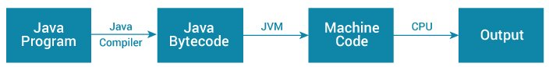

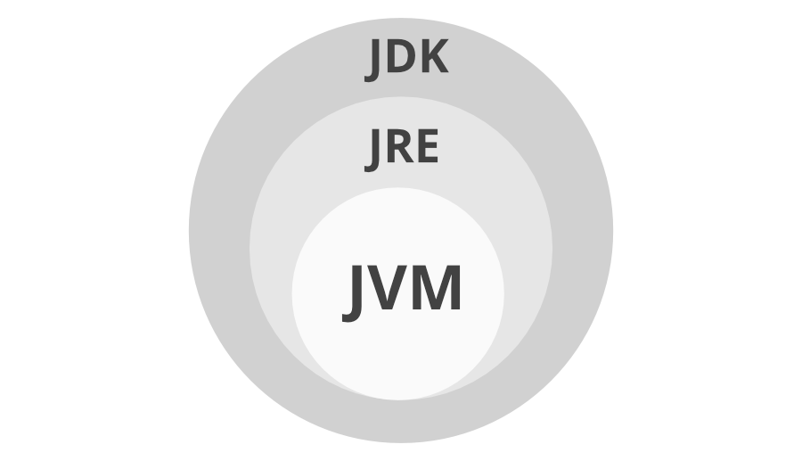

**Java Virtual Machine (JVM)** is a engine that provides runtime environment to drive the Java Code or applications. It converts Java bytecode into machines language. JVM is a part of Java Runtime Environment (JRE).

Example:

**package** com.demo;

**public** **class** Student {

**int** id=30;

String name="abhas";

String address="hyd";

**static** **int** *salary*=6000;

**void** eat()

{

System.***out***.println("instance method");

}

**static** **void** display()

{

System.***out***.println("static method");

}

**public** **static** **void** main(String[] args) {

System.***out***.println(Student.*salary*);

Student.*display*();

Student s=**new** Student();

s.eat();

}

}

JVM Architecture:

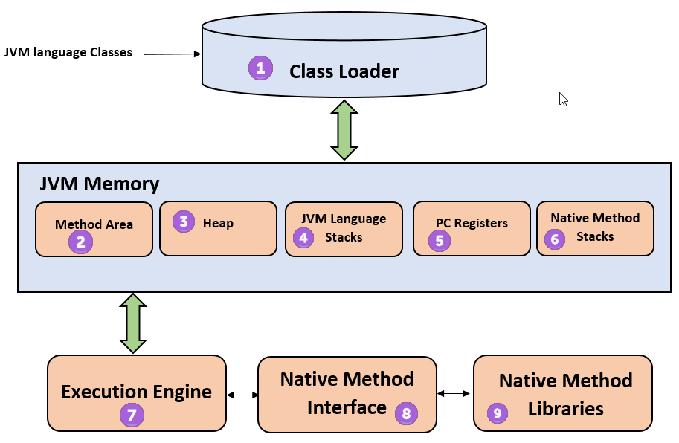

**1) ClassLoader**

The class loader is a subsystem used for loading class files.

### **2) Class(Method) Area**

Class(Method) Area stores per-class structures such as the runtime constant pool, field and method data, the code for methods.

### **3) Heap**

It is the runtime data area in which objects are allocated.

### **4) Stack**

Java Stack stores frames. It holds local variables and partial results, and plays a part in method invocation and return.

### **5) Program Counter Register**

PC (program counter) register contains the address of the Java virtual machine instruction currently being executed.

### **6) Native Method Stack**

It contains all the native methods used in the application.

### **7) Execution Engine**

It contains:

1. **A virtual processor**
2. **Interpreter:** Read bytecode stream then execute the instructions.
3. **Just-In-Time(JIT) compiler:** It is used to improve the performance. JIT compiles parts of the byte code that have similar functionality at the same time, and hence reduces the amount of time needed for compilation. Here, the term "compiler" refers to a translator from the instruction set of a Java virtual machine (JVM) to the instruction set of a specific CPU.

## Java Data Types:

1. **Primitive Data Types** :- which include integer, character, boolean, and float
2. **Non-primitive Data Types** :- which include classes, arrays and interfaces.

## Byte,short,char,int,long.float,double,Boolean

## Java Data Types

As the name suggests, data types specify the type of data that can be stored inside [variables in Java](https://www.programiz.com/java-programming/variables-literals).

Java is a statically-typed language. This means that all variables must be declared before they can be used.

int speed;

Here, speed is a variable, and the data type of the variable is int.

The int data type determines that the speed variable can only contain integers.

There are 8 data types predefined in Java, known as primitive data types.

**Note**: In addition to primitive data types, there are also referenced types (object type).

## 8 Primitive Data Types

### 1. boolean type

* The boolean data type has two possible values, either true or false.
* Default value: false.
* They are usually used for **true/false** conditions.

### Example 1: Java boolean data type

class Main {

public static void main(String[] args) {

boolean flag = true;

System.out.println(flag); // prints true

}

}

### 2. byte type

* The byte data type can have values from **-128** to **127** (8-bit signed two's complement integer).
* If it's certain that the value of a variable will be within -128 to 127, then it is used instead of int to save memory.
* Default value: 0

### Example 2: Java byte data type

class Main {

public static void main(String[] args) {

byte range;

range = 124;

System.out.println(range); // prints 124

}

}

### 3. short type

* The short data type in Java can have values from **-32768** to **32767** (16-bit signed two's complement integer).
* If it's certain that the value of a variable will be within -32768 and 32767, then it is used instead of other integer data types (int, long).
* Default value: 0

### Example 3: Java short data type

class Main {

public static void main(String[] args) {

short temperature;

temperature = -200;

System.out.println(temperature); // prints -200

}

}

### 4. int type

* The int data type can have values from **-231** to **231-1** (32-bit signed two's complement integer).
* If you are using Java 8 or later, you can use an unsigned 32-bit integer. This will have a minimum value of 0 and a maximum value of 232-1. To learn more, visit [How to use the unsigned integer in java 8?](http://stackoverflow.com/questions/25556017/how-to-use-the-unsigned-integer-in-java-8)
* Default value: 0

### Example 4: Java int data type

class Main {

public static void main(String[] args) {

int range = -4250000;

System.out.println(range); // print -4250000

}

}

### 5. long type

* The long data type can have values from **-263** to **263-1** (64-bit signed two's complement integer).
* If you are using Java 8 or later, you can use an unsigned 64-bit integer with a minimum value of **0** and a maximum value of **264-1**.
* Default value: 0

### Example 5: Java long data type

class LongExample {

public static void main(String[] args) {

long range = -42332200000L;

System.out.println(range); // prints -42332200000

}

}

Notice, the use of L at the end of -42332200000. This represents that it's an integer of the long type.

### 6. double type

* The double data type is a double-precision 64-bit floating-point.
* It should never be used for precise values such as currency.
* Default value: 0.0 (0.0d)

### Example 6: Java double data type

class Main {

public static void main(String[] args) {

double number = -42.3;

System.out.println(number); // prints -42.3

}

}

### 7. float type

* The float data type is a single-precision 32-bit floating-point. Learn more about [single-precision and double-precision floating-point](http://stackoverflow.com/questions/801117/whats-the-difference-between-a-single-precision-and-double-precision-floating-p) if you are interested.
* It should never be used for precise values such as currency.
* Default value: 0.0 (0.0f)

### Example 7: Java float data type

class Main {

public static void main(String[] args) {

float number = -42.3f;

System.out.println(number); // prints -42.3

}

}

Notice that we have used -42.3f instead of -42.3in the above program. It's because -42.3 is a double literal.

To tell the compiler to treat -42.3 as float rather than double, you need to use f or F.

If you want to know about single-precision and double-precision, visit [Java single-precision and double-precision floating-point](http://stackoverflow.com/questions/801117/whats-the-difference-between-a-single-precision-and-double-precision-floating-p).

### 8. char type

* It's a 16-bit Unicode character.
* The minimum value of the char data type is '\u0000' (0) and the maximum value of the is '\uffff'.
* Default value: '\u0000'

### Example 8: Java char data type

class Main {

public static void main(String[] args) {

char letter = '\u0051';

System.out.println(letter); // prints Q

}

}

Here, the Unicode value of Q is **\u0051**. Hence, we get Q as the output.

Here is another example:

class Main {

public static void main(String[] args) {

char letter1 = '9';

System.out.println(letter1); // prints 9

char letter2 = 65;

System.out.println(letter2); // prints A

}

}

Here, we have assigned 9 as a character (specified by single quotes) to the letter1 variable. However, the letter2 variable is assigned 65 as an integer number (no single quotes).

Hence, A is printed to the output. It is because Java treats characters as an integer and the ASCII value of A is 65. To learn more about ASCII, visit [What is ASCII Code?](https://www.ascii-code.com/).

### String type

Java also provides support for character strings via java.lang.String class. Strings in Java are not primitive types. Instead, they are objects. For example,

String myString = "Java Programming";

## Types of variables

In Java, there are three types of variables:

1. Local Variables
2. Instance Variables
3. Static Variables

### 1) Local Variables

Local Variables are a variable that are declared inside the body of a method.

### 2) Instance Variables

Instance variables are defined without the STATIC keyword .They are defined Outside a method declaration. They are Object specific and are known as instance variables.

### 3) Static Variables

Static variables are initialized only once, at the start of the program execution. These variables should be initialized first, before the initialization of any instance variables.

Example:

class Guru99 {

static int a = 1; //static variable

int data = 99; //instance variable

void method() {

int b = 90; //local variable

}

}

# Java Operators

Operators in Java can be classified into 5 types:

1. Arithmetic Operators
2. Assignment Operators
3. Relational Operators
4. Logical Operators
5. Unary Operators
6. Bitwise Operators

## 1. Java Arithmetic Operators

Arithmetic operators are used to perform arithmetic operations on variables and data. For example,

a + b;

Here, the + operator is used to add two variables a and b. Similarly, there are various other arithmetic operators in Java.

|  |  |
| --- | --- |
| Operator | Operation |
| + | Addition |
| - | Subtraction |
| \* | Multiplication |
| / | Division |
| % | Modulo Operation (Remainder after division) |

### Example 1: Arithmetic Operators

class Main {

public static void main(String[] args) {

// declare variables

int a = 12, b = 5;

// addition operator

System.out.println("a + b = " + (a + b));

// subtraction operator

System.out.println("a - b = " + (a - b));

// multiplication operator

System.out.println("a \* b = " + (a \* b));

// division operator

System.out.println("a / b = " + (a / b));

// modulo operator

System.out.println("a % b = " + (a % b));

}

}

**Output**

a + b = 17

a - b = 7

a \* b = 60

a / b = 2

a % b = 2

In the above example, we have used +, -, and \* operators to compute addition, subtraction, and multiplication operations.

**/ Division Operator**

Note the operation, a / b in our program. The / operator is the division operator.

If we use the division operator with two integers, then the resulting quotient will also be an integer. And, if one of the operands is a floating-point number, we will get the result will also be in floating-point.

In Java,

(9 / 2) is 4

(9.0 / 2) is 4.5

(9 / 2.0) is 4.5

(9.0 / 2.0) is 4.5

**% Modulo Operator**

The modulo operator % computes the remainder. When a = 7 is divided by b = 4, the remainder is **3**.

**Note**: The % operator is mainly used with integers.

## 2. Java Assignment Operators

Assignment operators are used in Java to assign values to variables. For example,

int age;

age = 5;

Here, = is the assignment operator. It assigns the value on its right to the variable on its left. That is, **5** is assigned to the variable age.

Let's see some more assignment operators available in Java.

|  |  |  |
| --- | --- | --- |
| Operator | Example | Equivalent to |
| = | a = b; | a = b; |
| += | a += b; | a = a + b; |
| -= | a -= b; | a = a - b; |
| \*= | a \*= b; | a = a \* b; |
| /= | a /= b; | a = a / b; |
| %= | a %= b; | a = a % b; |

### Example 2: Assignment Operators

class Main {

public static void main(String[] args) {

// create variables

int a = 4;

int var;

// assign value using =

var = a;

System.out.println("var using =: " + var);

// assign value using =+

var += a;

System.out.println("var using +=: " + var);

// assign value using =\*

var \*= a;

System.out.println("var using \*=: " + var);

}

}

**Output**

var using =: 4

var using +=: 8

var using \*=: 32

## 3. Java Relational Operators

Relational operators are used to check the relationship between two operands. For example,

// check if a is less than b

a < b;

Here, < operator is the relational operator. It checks if a is less than b or not.

It returns either true or false.

|  |  |  |
| --- | --- | --- |
| Operator | Description | Example |
| == | Is Equal To | 3 == 5 returns **false** |
| != | Not Equal To | 3 != 5 returns **true** |
| > | Greater Than | 3 > 5 returns **false** |
| < | Less Than | 3 < 5 returns **true** |
| >= | Greater Than or Equal To | 3 >= 5 returns **false** |
| <= | Less Than or Equal To | 3 <= 5 returns **true** |

### Example 3: Relational Operators

class Main {

public static void main(String[] args) {

// create variables

int a = 7, b = 11;

// value of a and b

System.out.println("a is " + a + " and b is " + b);

// == operator

System.out.println(a == b); // false

// != operator

System.out.println(a != b); // true

// > operator

System.out.println(a > b); // false

// < operator

System.out.println(a < b); // true

// >= operator

System.out.println(a >= b); // false

// <= operator

System.out.println(a <= b); // true

}

}

**Note**: Relational operators are used in decision making and loops.

## 4. Java Logical Operators

Logical operators are used to check whether an expression is true or false. They are used in decision making.

|  |  |  |
| --- | --- | --- |
| Operator | Example | Meaning |
| && (Logical AND) | expression1 **&&** expression2 | true only if both expression1 and expression2 are true |
| || (Logical OR) | expression1 **||** expression2 | true if either expression1 or expression2 is true |
| ! (Logical NOT) | **!**expression | true if expression is false and vice versa |

### Example 4: Logical Operators

class Main {

public static void main(String[] args) {

// && operator

System.out.println((5 > 3) && (8 > 5)); // true

System.out.println((5 > 3) && (8 < 5)); // false

// || operator

System.out.println((5 < 3) || (8 > 5)); // true

System.out.println((5 > 3) || (8 < 5)); // true

System.out.println((5 < 3) || (8 < 5)); // false

// ! operator

System.out.println(!(5 == 3)); // true

System.out.println(!(5 > 3)); // false

}

}

**Working of Program**

* (5 > 3) && (8 > 5) returns true because both (5 > 3) and (8 > 5) are true.
* (5 > 3) && (8 < 5) returns false because the expression (8 < 5) is false.
* (5 < 3) || (8 > 5) returns true because the expression (8 > 5) is true.
* (5 > 3) && (8 > 5) returns true because the expression (5 > 3) is true.
* (5 > 3) && (8 > 5) returns false because both (5 < 3) and (8 < 5) are false.
* !(5 == 3) returns true because 5 == 3 is false.
* !(5 > 3) returns false because 5 > 3 is true.

## 5. Java Unary Operators

Unary operators are used with only one operand. For example, ++ is a unary operator that increases the value of a variable by **1**. That is, ++5 will return **6**.

Different types of unary operators are:

|  |  |
| --- | --- |
| Operator | Meaning |
| + | **Unary plus**: not necessary to use since numbers are positive without using it |
| - | **Unary minus**: inverts the sign of an expression |
| ++ | **Increment operator**: increments value by 1 |
| -- | **Decrement operator**: decrements value by 1 |
| ! | **Logical complement operator**: inverts the value of a boolean |

## Increment and Decrement Operators

Java also provides increment and decrement operators: ++ and -- respectively. ++ increases the value of the operand by **1**, while -- decrease it by **1**. For example,

int num = 5;

// increase num by 1

++num;

Here, the value of num gets increased to **6** from its initial value of **5**.

### Example 5: Increment and Decrement Operators

class Main {

public static void main(String[] args) {

// declare variables

int a = 12, b = 12;

int result1, result2;

// original value

System.out.println("Value of a: " + a);

// increment operator

result1 = ++a;

System.out.println("After increment: " + result1);

System.out.println("Value of b: " + b);

// decrement operator

result2 = --b;

System.out.println("After decrement: " + result2);

}

}

**Output**

Value of a: 12

After increment: 13

Value of b: 12

After decrement: 11

In the above program, we have used the ++ and -- operator as **prefixes (++a, --b)**. We can also use these operators as **postfix (a++, b++)**.

There is a slight difference when these operators are used as prefix versus when they are used as a postfix.

To learn more about these operators, visit [increment and decrement operators](https://www.programiz.com/article/increment-decrement-operator-difference-prefix-postfix).

### Java Ternary Operator

The ternary operator (conditional operator) is shorthand for the if-then-else statement. For example,

variable = Expression ? expression1 : expression2

Here's how it works.

* If the Expression is true, expression1 is assigned to the variable.
* If the Expression is false, expression2 is assigned to the variable.

Let's see an example of a ternary operator.

class Java {

public static void main(String[] args) {

int februaryDays = 29;

String result;

// ternary operator

result = (februaryDays == 28) ? "Not a leap year" : "Leap year";

System.out.println(result);

}

}

**Output**

Leap year

## OOPs (Object-Oriented Programming System)

**Object** means a real-world entity such as a pen, chair, table, computer, watch, etc. **Object-Oriented Programming** is a methodology or paradigm to design a program using classes and objects. It simplifies software development and maintenance by providing some concepts:

* [Object](https://www.javatpoint.com/object-and-class-in-java)
* Class
* [Inheritance](https://www.javatpoint.com/inheritance-in-java)
* [Polymorphism](https://www.javatpoint.com/runtime-polymorphism-in-java)
* [Abstraction](https://www.javatpoint.com/abstract-class-in-java)
* [Encapsulation](https://www.javatpoint.com/encapsulation)

Apart from these concepts, there are some other terms which are used in Object-Oriented design:

* Coupling
* Cohesion
* Association
* Aggregation
* Composition

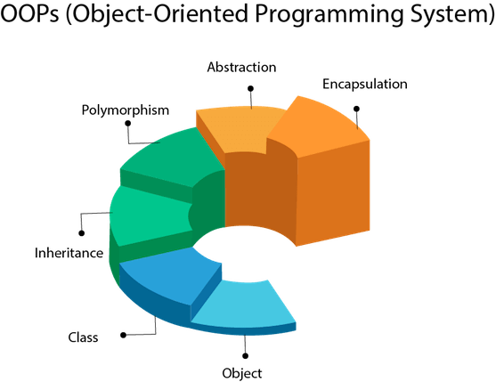

An object in Java is the physical as well as a logical entity, whereas, a class in Java is a logical entity only.

### **What is an object in Java**

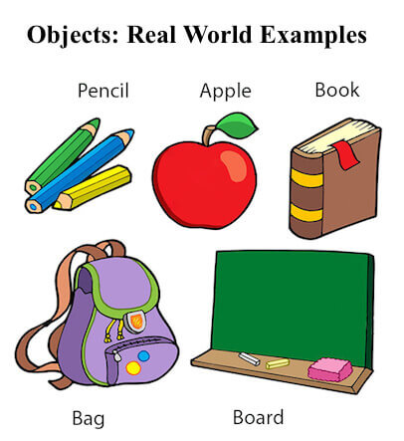

An entity that has state and behavior is known as an object e.g., chair, bike, marker, pen, table, car, etc. It can be physical or logical (tangible and intangible). The example of an intangible object is the banking system.

An object has three characteristics:

* **State:** represents the data (value) of an object.
* **Behavior:** represents the behavior (functionality) of an object such as deposit, withdraw, etc.
* **Identity:** An object identity is typically implemented via a unique ID. The value of the ID is not visible to the external user. However, it is used internally by the JVM to identify each object uniquely.

**An object is an instance of a class.** A class is a template or blueprint from which objects are created. So, an object is the instance(result) of a class.

## What is a class in Java

A class is a group of objects which have common properties. It is a template or blueprint from which objects are created. It is a logical entity. It can't be physical.

A class in Java can contain:

* **Fields**
* **Methods**
* **Constructors**
* **Blocks**
* **Nested class and interface**

### **Method in Java**

In Java, a method is like a function which is used to expose the behavior of an object.

#### **Advantage of Method**

* Code Reusability
* Code Optimization

### **new keyword in Java**

The new keyword is used to allocate memory at runtime. All objects get memory in Heap memory area.

### **Object and Class Example: Initialization through method**

In this example, we are creating the two objects of Student class and initializing the value to these objects by invoking the insertRecord method. Here, we are displaying the state (data) of the objects by invoking the displayInformation() method.

*File: TestStudent4.java*

1. **class** Student{
2. **int** rollno;
3. String name;
4. **void** insertRecord(**int** r, String n){
5. rollno=r;
6. name=n;
7. }
8. **void** displayInformation(){
9. System.out.println(rollno+" "+name);}
10. }
11. **class** TestStudent4{
12. **public** **static** **void** main(String args[]){
13. Student s1=**new** Student();
14. Student s2=**new** Student();
15. s1.insertRecord(111,"Karan");
16. s2.insertRecord(222,"Aryan");
17. s1.displayInformation();
18. s2.displayInformation();
19. }
20. }

[**Test it Now**](https://www.javatpoint.com/opr/test.jsp?filename=TestStudent4)

Output:

111 Karan

222 Aryan

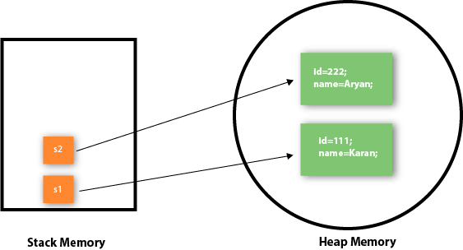

## Java Methods

A method is a block of code that performs a specific task.

Suppose you need to create a program to create a circle and color it. You can create two methods to solve this problem:

* a method to draw the circle
* a method to color the circle

Dividing a complex problem into smaller chunks makes your program easy to understand and reusable.

In Java, there are two types of methods:

* **User-defined Methods**: We can create our own method based on our requirements.
* **Standard Library Methods**: These are built-in methods in Java that are available to use.

Let's first learn about user-defined methods.

## Declaring a Java Method

## Method in Java

* **Public:** The method is accessible by all classes when we use public specifier in our application.
* **Private:** When we use a private access specifier, the method is accessible only in the classes in which it is defined.
* **Protected:** When we use protected access specifier, the method is accessible within the same package or subclasses in a different package.
* **Default:** When we do not use any access specifier in the method declaration, Java uses default access specifier by default. It is visible only from the same package only.

**Return Type:** Return type is a data type that the method returns. It may have a primitive data type, object, collection, void, etc. If the method does not return anything, we use void keyword.

**Method Name:** It is a unique name that is used to define the name of a method. It must be corresponding to the functionality of the method.

**Parameter List:** It is the list of parameters separated by a comma and enclosed in the pair of parentheses.

**Method Body:** It is a part of the method declaration. It contains all the actions to be performed. It is enclosed within the pair of curly braces.

## Types of Method

There are two types of methods in Java:

* Predefined Method
* User-defined Method

Let's see an example of the predefined method.

**Demo.java**

1. **public** **class** Demo
2. {
3. **public** **static** **void** main(String[] args)
4. {
5. // using the max() method of Math class
6. System.out.print("The maximum number is: " + Math.max(9,7));
7. }
8. }

**Addition.java**

1. **package** com.demo;
2. **public** **class** Addition {
3. **public** **int** sum(**int** a,**int** b)
4. {
5. **int** c=a+b;
6. **return** c;
8. }
9. **public** **static** **void** main(String[] args) {
11. Addition add=**new** Addition();
13. **int** d=add.sum(10, 40);
15. System.***out***.println(d);

18. }
19. }
20. }

**Output:**

The sum of a and b is= 24

**package** com.demo;

**public** **class** Main {

// create a method

**public** **int** addNumbers(**int** a, **int** b) {

**int** sum = a + b;

// return value

**return** sum;

}

**public** **static** **void** main(String[] args) {

**int** num1 = 25;

**int** num2 = 15;

// create an object of Main

Main obj = **new** Main();

// calling method

**int** result = obj.addNumbers(num1, num2);

System.***out***.println("Sum is: " + result);

}

}

**package** com.demo;

**public** **class** Main {

// method with no parameter

**public** **void** display1() {

System.***out***.println("Method without parameter");

}

// method with single parameter

**public** **void** display2(**int** a) {

System.***out***.println("Method with a single parameter: " + a);

}

**public** **static** **void** main(String[] args) {

// create an object of Main

Main obj = **new** Main();

// calling method with no parameter

obj.display1();

// calling method with the single parameter

obj.display2(24);

}

}

# **Constructors in Java**

A constructor in Java is similar to a method that is invoked when an object of the class is created.

Every time an object is created using the new() keyword, at least one constructor is called.

It calls a default constructor if there is no constructor available in the class. In such case, Java compiler provides a default constructor by default.

There are two types of constructors in Java: no-arg constructor, and parameterized constructor.

**Note:** It is called constructor because it constructs the values at the time of object creation

### **Rules for creating Java constructor**

There are two rules defined for the constructor.

1. Constructor name must be the same as its class name
2. A Constructor must have no explicit return type
3. A Java constructor cannot be abstract, static, final, and synchronized

## Types of Java constructors

There are two types of constructors in Java:

1. Default constructor (no-arg constructor)
2. Parameterized constructor

## Java Default Constructor

A constructor is called "Default Constructor" when it doesn't have any parameter.

## Example of default constructor

|  |
| --- |
| In this example, we are creating the no-arg constructor in the Bike class.  It will be invoked at the time of object creation. |

//Java Program to create and call a default constructor

1. **class** Bike1{
2. //creating a default constructor
3. Bike1(){
4. System.out.println("Bike is created");
5. }
6. //main method
7. **public** **static** **void** main(String args[]){
8. //calling a default constructor
9. Bike1 b=**new** Bike1();
10. }
11. }

### **Q) What is the purpose of a default constructor?**

The default constructor is used to provide the default values to the object like 0, null, etc., depending on the type.

### **Example of default constructor that displays the default values**

1. //Let us see another example of default constructor
2. //which displays the default values
3. **class** Student3{
4. **int** id;
5. String name;
6. //method to display the value of id and name
7. **void** display(){
8. System.out.println(id+" "+name);
9. }
11. **public** **static** **void** main(String args[]){
12. //creating objects
13. Student3 s1=**new** Student3();
14. Student3 s2=**new** Student3();
15. //displaying values of the object
16. s1.display();
17. s2.display();
18. }
19. }

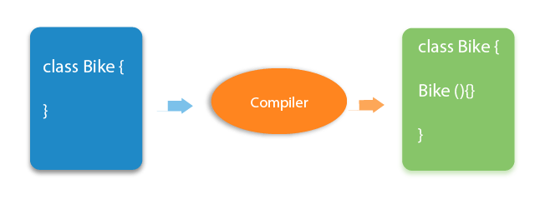

### **Java Parameterized Constructor**

A constructor which has a specific number of parameters is called a parameterized constructor.

### **Why use the parameterized constructor?**

The parameterized constructor is used to provide different values to distinct objects

### **Example of parameterized constructor**

In this example, we have created the constructor of Student class that have two parameters. We can have any number of parameters in the constructor.

//Java Program to demonstrate the use of the parameterized constructor.

1. **class** Student4{
2. **int** id;
3. String name;
4. //creating a parameterized constructor
5. Student4(**int** i,String n){
6. id = i;
7. name = n;
8. }
9. //method to display the values
10. **void** display(){
11. System.out.println(id+" "+name);
12. }
14. **public** **static** **void** main(String args[]){
15. //creating objects and passing values
16. Student4 s1 = **new** Student4(111,"Karan");
17. Student4 s2 = **new** Student4(222,"Aryan");
18. //calling method to display the values of object
19. s1.display();
20. s2.display();
21. }
22. }

# **Java static keyword**

The **static keyword** in [Java](https://www.javatpoint.com/java-tutorial)

is used for memory management mainly. We can apply static keyword with [variables](https://www.javatpoint.com/java-variables)

, methods, blocks and

. The static keyword belongs to the class than an instance of the class.

The static can be:

1. Variable (also known as a class variable)
2. Method (also known as a class method)
3. Block

## 1) Java static variable

* The static variable can be used to refer to the common property of all objects (which is not unique for each object), for example, the company name of employees, college name of students, etc.
* The static variable gets memory only once in the class area at the time of class loading.

### **Example of static variable**

//Java Program to demonstrate the use of static variable

1. **class** Student{
2. **int** rollno;//instance variable
3. String name;
4. **static** String college ="ITS";//static variable
5. //constructor
6. Student(**int** r, String n){
7. rollno = r;
8. name = n;
9. }
10. //method to display the values
11. **void** display (){System.out.println(rollno+" "+name+" "+college);}
12. }
13. //Test class to show the values of objects
14. **public** **class** TestStaticVariable1{
15. **public** **static** **void** main(String args[]){
16. Student s1 = **new** Student(111,"Karan");
17. Student s2 = **new** Student(222,"Aryan");
18. //we can change the college of all objects by the single line of code
19. //Student.college="BBDIT";
20. s1.display();
21. s2.display();
22. }
23. }

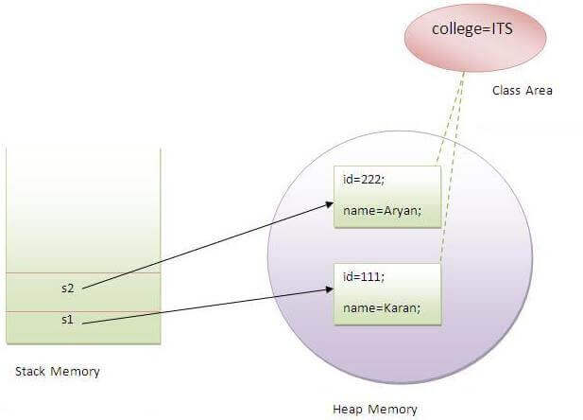

## 2) Java static method

If you apply static keyword with any method, it is known as static method.

* A static method belongs to the class rather than the object of a class.
* A static method can be invoked without the need for creating an instance of a class.
* A static method can access static data member and can change the value of it.

### **Example of static method**

1. //Java Program to demonstrate the use of a static method.
2. **class** Student{
3. **int** rollno;
4. String name;
5. **static** String college = "ITS";
6. //static method to change the value of static variable
7. **static** **void** change(){
8. college = "BBDIT";
9. }
10. //constructor to initialize the variable
11. Student(**int** r, String n){
12. rollno = r;
13. name = n;
14. }
15. //method to display values
16. **void** display(){System.out.println(rollno+" "+name+" "+college);}
17. }
18. //Test class to create and display the values of object
19. **public** **class** TestStaticMethod{
20. **public** **static** **void** main(String args[]){
21. Student.change();//calling change method
22. //creating objects
23. Student s1 = **new** Student(111,"Karan");
24. Student s2 = **new** Student(222,"Aryan");
25. Student s3 = **new** Student(333,"Sonoo");
26. //calling display method
27. s1.display();
28. s2.display();
29. s3.display();
30. }
31. }

[**Test it Now**](https://www.javatpoint.com/opr/test.jsp?filename=TestStaticMethod)

Output:111 Karan BBDIT

222 Aryan BBDIT

333 Sonoo BBDIT

### **Another example of a static method that performs a normal calculation**

1. //Java Program to get the cube of a given number using the static method
3. **class** Calculate{
4. **static** **int** cube(**int** x){
5. **return** x\*x\*x;
6. }
8. **public** **static** **void** main(String args[]){
9. **int** result=Calculate.cube(5);
10. System.out.println(result);
11. }
12. }

[**Test it Now**](https://www.javatpoint.com/opr/test.jsp?filename=Calculate)

Output:125

### **Restrictions for the static method**

There are two main restrictions for the static method. They are:

1. The static method can not use non static data member or call non-static method directly.
2. this and super cannot be used in static context.
3. **class** A{
4. **int** a=40;//non static
6. **public** **static** **void** main(String args[]){
7. System.out.println(a);
8. }
9. }

[**Test it Now**](https://www.javatpoint.com/opr/test.jsp?filename=A)

Output:Compile Time Error

### **Q) Why is the Java main method static?**

Ans) It is because the object is not required to call a static method. If it were a non-static method, [JVM](https://www.javatpoint.com/jvm-java-virtual-machine) creates an object first then call main() method that will lead the problem of extra memory allocation.

## 3) Java static block

* Is used to initialize the static data member.
* It is executed before the main method at the time of classloading.

### **Example of static block**

1. **class** A2{
2. **static**{System.out.println("static block is invoked");}
3. **public** **static** **void** main(String args[]){
4. System.out.println("Hello main");
5. }
6. }

[**Test it Now**](https://www.javatpoint.com/opr/test.jsp?filename=A2)

Output:static block is invoked

Hello main

# **this keyword in Java**

 In Java, this is a **reference variable** that refers to the current object.

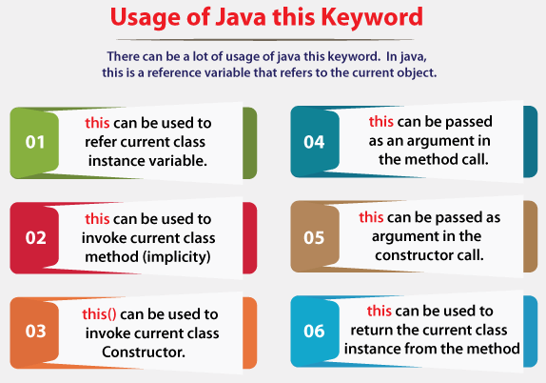

### **1) this: to refer current class instance variable**

The this keyword can be used to refer current class instance variable. If there is ambiguity between the instance variables and parameters, this keyword resolves the problem of ambiguity.

6.4M

78

Crypto Market Plunges $130 Billion in 24 Hours

#### **Understanding the problem without this keyword**

Let's understand the problem if we don't use this keyword by the example given below:

1. **class** Student{
2. **int** rollno;
3. String name;
4. **float** fee;
5. Student(**int** rollno,String name,**float** fee){
6. rollno=rollno;
7. name=name;
8. fee=fee;
9. }
10. **void** display(){System.out.println(rollno+" "+name+" "+fee);}
11. }
12. **class** TestThis1{
13. **public** **static** **void** main(String args[]){
14. Student s1=**new** Student(111,"ankit",5000f);
15. Student s2=**new** Student(112,"sumit",6000f);
16. s1.display();
17. s2.display();
18. }}

**[Test it Now](https://www.javatpoint.com/opr/test.jsp?filename=TestThis1" \t "_blank)**

**Output:**

0 null 0.0

0 null 0.0

In the above example, parameters (formal arguments) and instance variables are same. So, we are using this keyword to distinguish local variable and instance variable.

#### **Solution of the above problem by this keyword**

1. **class** Student{
2. **int** rollno;
3. String name;
4. **float** fee;
5. Student(**int** rollno,String name,**float** fee){
6. **this**.rollno=rollno;
7. **this**.name=name;
8. **this**.fee=fee;
9. }
10. **void** display(){System.out.println(rollno+" "+name+" "+fee);}
11. }
13. **class** TestThis2{
14. **public** **static** **void** main(String args[]){
15. Student s1=**new** Student(111,"ankit",5000f);
16. Student s2=**new** Student(112,"sumit",6000f);
17. s1.display();
18. s2.display();
19. }}

**[Test it Now](https://www.javatpoint.com/opr/test.jsp?filename=TestThis2" \t "_blank)**

**Output:**

111 ankit 5000.0

112 sumit 6000.0

If local variables(formal arguments) and instance variables are different, there is no need to use this keyword like in the following program:

#### **Program where this keyword is not required**

1. **class** Student{
2. **int** rollno;
3. String name;
4. **float** fee;
5. Student(**int** r,String n,**float** f){
6. rollno=r;
7. name=n;
8. fee=f;
9. }
10. **void** display(){System.out.println(rollno+" "+name+" "+fee);}
11. }
13. **class** TestThis3{
14. **public** **static** **void** main(String args[]){
15. Student s1=**new** Student(111,"ankit",5000f);
16. Student s2=**new** Student(112,"sumit",6000f);
17. s1.display();
18. s2.display();
19. }}

**[Test it Now](https://www.javatpoint.com/opr/test.jsp?filename=TestThis3" \t "_blank)**

**Output:**

111 ankit 5000.0

112 sumit 6000.0

### **2) this: to invoke current class method**

You may invoke the method of the current class by using the this keyword. If you don't use the this keyword, compiler automatically adds this keyword while invoking the method. Let's see the example

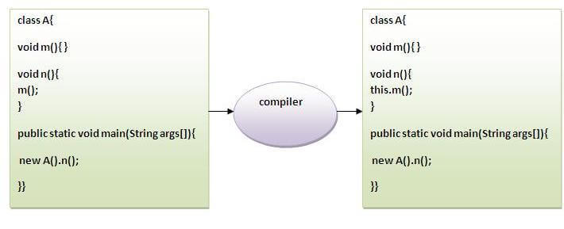

1. **class** A{
2. **void** m(){System.out.println("hello m");}
3. **void** n(){
4. System.out.println("hello n");
5. //m();//same as this.m()
6. **this**.m();
7. }
8. }
9. **class** TestThis4{
10. **public** **static** **void** main(String args[]){
11. A a=**new** A();
12. a.n();
13. }}

**[Test it Now](https://www.javatpoint.com/opr/test.jsp?filename=TestThis4" \t "_blank)**

**Output:**

hello n

hello m

### **3) this() : to invoke current class constructor**

The this() constructor call can be used to invoke the current class constructor. It is used to reuse the constructor. In other words, it is used for constructor chaining.

**Calling default constructor from parameterized constructor:**

1. **class** A{
2. A(){
3. System.out.println("hello a");
4. }
5. A(**int** x){
6. **this**();
7. System.out.println(x);
8. }
9. }
10. **class** TestThis5{
11. **public** **static** **void** main(String args[]){
12. A a=**new** A(10);
13. }}

**[Test it Now](https://www.javatpoint.com/opr/test.jsp?filename=TestThis5" \t "_blank)**

**Output:**

hello a

10

**Calling parameterized constructor from default constructor:**

1. **class** A{
2. A(){
3. **this**(5);
4. System.out.println("hello a");
5. }
6. A(**int** x){
7. System.out.println(x);
8. }
9. }
10. **class** TestThis6{
11. **public** **static** **void** main(String args[]){
12. A a=**new** A();
13. }}

**[Test it Now](https://www.javatpoint.com/opr/test.jsp?filename=TestThis6" \t "_blank)**

**Output:**

5

hello a

### **Real usage of this() constructor call**

The this() constructor call should be used to reuse the constructor from the constructor. It maintains the chain between the constructors i.e. it is used for constructor chaining. Let's see the example given below that displays the actual use of this keyword.

1. **class** Student{
2. **int** rollno;
3. String name,course;
4. **float** fee;
5. Student(**int** rollno,String name,String course){
6. **this**.rollno=rollno;
7. **this**.name=name;
8. **this**.course=course;
9. }
10. Student(**int** rollno,String name,String course,**float** fee){
11. **this**(rollno,name,course);//reusing constructor
12. **this**.fee=fee;
13. }
14. **void** display(){System.out.println(rollno+" "+name+" "+course+" "+fee);}
15. }
16. **class** TestThis7{
17. **public** **static** **void** main(String args[]){
18. Student s1=**new** Student(111,"ankit","java");
19. Student s2=**new** Student(112,"sumit","java",6000f);
20. s1.display();
21. s2.display();
22. }}

**[Test it Now](https://www.javatpoint.com/opr/test.jsp?filename=TestThis7" \t "_blank)**

**Output:**

111 ankit java 0.0

112 sumit java 6000.0

#### **Rule: Call to this() must be the first statement in constructor.**

1. **class** Student{
2. **int** rollno;
3. String name,course;
4. **float** fee;
5. Student(**int** rollno,String name,String course){
6. **this**.rollno=rollno;
7. **this**.name=name;
8. **this**.course=course;
9. }
10. Student(**int** rollno,String name,String course,**float** fee){
11. **this**.fee=fee;
12. **this**(rollno,name,course);//C.T.Error
13. }
14. **void** display(){System.out.println(rollno+" "+name+" "+course+" "+fee);}
15. }
16. **class** TestThis8{
17. **public** **static** **void** main(String args[]){
18. Student s1=**new** Student(111,"ankit","java");
19. Student s2=**new** Student(112,"sumit","java",6000f);
20. s1.display();
21. s2.display();
22. }}

**[Test it Now](https://www.javatpoint.com/opr/test.jsp?filename=TestThis8" \t "_blank)**

**Output:**

Compile Time Error: Call to this must be first statement in constructor

# **Inheritance in Java:**

**Inheritance in Java** is a mechanism in which one object acquires all the properties and behaviors of a parent object. It is an important part of [OOPs](https://www.javatpoint.com/java-oops-concepts) (Object Oriented programming system).

The idea behind inheritance in Java is that you can create new [classes](https://www.javatpoint.com/object-and-class-in-java) that are built upon existing classes. When you inherit from an existing class, you can reuse methods and fields of the parent class. Moreover, you can add new methods and fields in your current class also.

Inheritance represents the **IS-A relationship** which is also known as a parent-child relationship.

### **Why use inheritance in java**

* For Code Reusability.

### **Terms used in Inheritance**

* **Class:** A class is a group of objects which have common properties. It is a template or blueprint from which objects are created.
* **Sub Class/Child Class:** Subclass is a class which inherits the other class. It is also called a derived class, extended class, or child class.
* **Super Class/Parent Class:** Superclass is the class from where a subclass inherits the features. It is also called a base class or a parent class.
* **Reusability:** As the name specifies, reusability is a mechanism which facilitates you to reuse the fields and methods of the existing class when you create a new class. You can use the same fields and methods already defined in the previous class.

### **The syntax of Java Inheritance**

1. **class** Subclass-name **extends** Superclass-name
2. {
3. //methods and fields
4. }

The **extends keyword** indicates that you are making a new class that derives from an existing class.

**class** Teacher{

String designation = "Teacher";

String collegeName = "Edureka";

**void** does(){

System.out.println("Teaching");

}

}

**public** **class** HadoopTeacher **extends** Teacher{

String mainSubject = "Spark";

**public** **static** **void** main(String args[]){

HadoopTeacher obj = **new** HadoopTeacher();

System.out.println(obj.collegeName);

System.out.println(obj.designation);

System.out.println(obj.mainSubject);

obj.does();

}

}

As displayed in the above figure, Programmer is the subclass and Employee is the superclass. The relationship between the two classes is **Programmer IS-A Employee**. It means that Programmer is a type of Employee.

1. **class** Employee{
2. **float** salary=40000;
3. }
4. **class** Programmer **extends** Employee{
5. **int** bonus=10000;
6. **public** **static** **void** main(String args[]){
7. Programmer p=**new** Programmer();
8. System.out.println("Programmer salary is:"+p.salary);
9. System.out.println("Bonus of Programmer is:"+p.bonus);
10. }
11. }

[**Test it Now**](https://www.javatpoint.com/opr/test.jsp?filename=Programmer)

Programmer salary is:40000.0

Bonus of programmer is:10000

In the above example, Programmer object can access the field of own class as well as of Employee class i.e. code reusability.

## Types of inheritance in java

On the basis of class, there can be three types of inheritance in java: single, multilevel and hierarchical.

In java programming, multiple and hybrid inheritance is supported through interface only. We will learn about interfaces later.

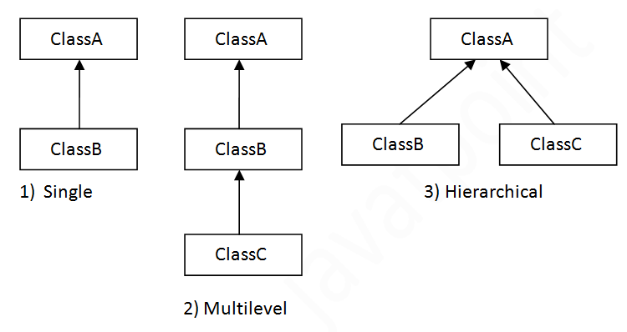

#### **Note: Multiple inheritance is not supported in Java through class.**

When one class inherits multiple classes, it is known as multiple inheritance. For Example:

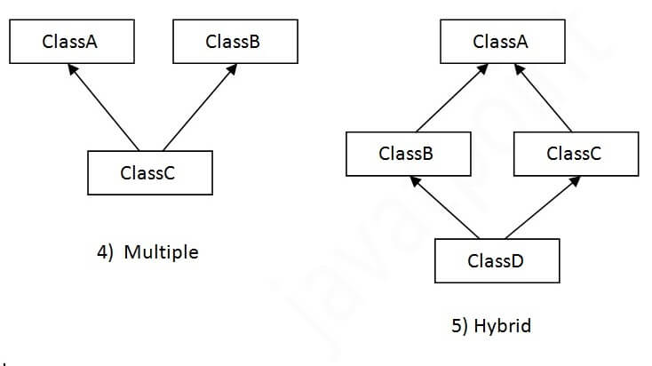

## Single Inheritance Example

When a class inherits another class, it is known as a single inheritance. In the example given below, Dog class inherits the Animal class, so there is the single inheritance.

*File: TestInheritance.java*

1. **class** Animal{
2. **void** eat(){System.out.println("eating...");}
3. }
4. **class** Dog **extends** Animal{
5. **void** bark(){System.out.println("barking...");}
6. }
7. **class** TestInheritance{
8. **public** **static** **void** main(String args[]){
9. Dog d=**new** Dog();
10. d.bark();
11. d.eat();
12. }}

Output:

barking...

eating...

## Multilevel Inheritance Example

When there is a chain of inheritance, it is known as multilevel inheritance. As you can see in the example given below, BabyDog class inherits the Dog class which again inherits the Animal class, so there is a multilevel inheritance.

*File: TestInheritance2.java*

1. **class** Animal{
2. **void** eat(){System.out.println("eating...");}
3. }
4. **class** Dog **extends** Animal{
5. **void** bark(){System.out.println("barking...");}
6. }
7. **class** BabyDog **extends** Dog{
8. **void** weep(){System.out.println("weeping...");}
9. }
10. **class** TestInheritance2{
11. **public** **static** **void** main(String args[]){
12. BabyDog d=**new** BabyDog();
13. d.weep();
14. d.bark();
15. d.eat();
16. }}

Output:

weeping...

barking...

eating...

## Hierarchical Inheritance Example

When two or more classes inherits a single class, it is known as hierarchical inheritance. In the example given below, Dog and Cat classes inherits the Animal class, so there is hierarchical inheritance.

*File: TestInheritance3.java*

1. **class** Animal{
2. **void** eat(){System.out.println("eating...");}
3. }
4. **class** Dog **extends** Animal{
5. **void** bark(){System.out.println("barking...");}
6. }
7. **class** Cat **extends** Animal{
8. **void** **meow**(){System.out.println("meowing...");}
9. }
10. **class** TestInheritance3{
11. **public** **static** **void** main(String args[]){
12. Cat c=**new** Cat();
13. c.meow();
14. c.eat();
15. //c.bark();//C.T.Error
16. }}

Output:

meowing...

eating...

## Q) Why multiple inheritance is not supported in java?

To reduce the complexity and simplify the language, multiple inheritance is not supported in java.

Consider a scenario where A, B, and C are three classes. The C class inherits A and B classes. If A and B classes have the same method and you call it from child class object, there will be ambiguity to call the method of A or B class.

Since compile-time errors are better than runtime errors, Java renders compile-time error if you inherit 2 classes. So whether you have same method or different, there will be compile time error.

1. **class** A{
2. **void** msg(){System.out.println("Hello");}
3. }
4. **class** B{
5. **void** msg(){System.out.println("Welcome");
6. }
7. **class** C **extends** A,B{//suppose if it were
9. **public** **static** **void** main(String args[]){
10. C obj=**new** C();
11. obj.msg();//Now which msg() method would be invoked?
12. }
13. }

[**Test it Now**](https://www.javatpoint.com/opr/test.jsp?filename=C)

Compile Time Error

# **Aggregation in Java**

If a class have an entity reference, it is known as Aggregation. Aggregation represents HAS-A relationship.

Consider a situation, Employee object contains many informations such as id, name, emailId etc. It contains one more object named address, which contains its own informations such as city, state, country, zipcode etc. as given below.

1. **class** Employee{
2. **int** id=20;
3. String name=”saaa”;
4. Address address=new Address();//Address is a class
5. ...
6. }

### **Why use Aggregation?**

* For Code Reusability.

#### **Address.java**

**public** **class** Address {

1. String city,state,country;
3. **public** Address(String city, String state, String country) {
4. **this**.city = city;
5. **this**.state = state;
6. **this**.country = country;
7. }
9. }
10. **public** **class** Emp {
11. **int** id;
12. String name;
13. Address address;
15. **public** Emp(**int** id, String name,Address address) {
16. **this**.id = id;
17. **this**.name = name;
18. **this**.address=address;
19. }
21. **void** display(){
22. System.out.println(id+" "+name);
23. System.out.println(address.city+" "+address.state+" "+address.country);
24. }
26. **public** **static** **void** main(String[] args) {
27. Address address1=**new** Address("gzb","UP","india");
28. Address address2=**new** Address("gno","UP","india");
30. Emp e=**new** Emp(111,"varun",address1);
31. Emp e2=**new** Emp(112,"arun",address2);
33. e.display();
34. e2.display();
36. }
37. }

**[Test it Now](https://www.javatpoint.com/opr/test.jsp?filename=Emp" \t "_blank)**

Output:111 varun

gzb UP india

112 arun

gno UP india